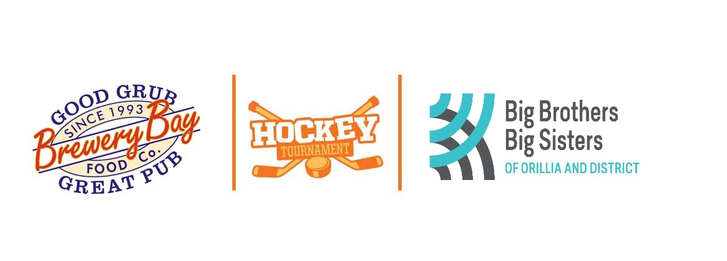

28th Annual Hockey Tournament
January 17th – 19th, 2020
Featuring:
- C.A.R.H.A Sanctioned, C.A.R.H.A. Rules
- Qualified CARHA Officials
- Guaranteed 3 Games
- Complimentary Post 3 Game Refreshments
- Player and Coach Tournament Souvenir to Division Finalists
- Men’s Divisions C, D, E, F Level, 35+, 45+ and 50+
- Women’s Recreational (minimum age 19 years)
- Majority of Games played at West Orillia Sports Complex (Rotary Place Arenas – 100 University Ave) Minutes from Casino Rama, close to Ski Hills, many quality Hotels

Entry Fee: $850.00 with deposit of $450.00 plus $400.00 post-dated
Cheque dated November 30th, 2019.
Enter Early, it’s as Always a Sell-out
Make cheques payable to:
Big Brothers Big Sisters of Orillia & District

17 Colborne St. East, Unit 102
Orillia, Ontario L3V 1T4
705-325-3151
Email: events@bbbsorillia.ca

All proceeds support free mentoring programs provided through Big Brothers Big Sisters, a registered recognized by the Canada Revenue Agency – CRA#10780 3546 RR0001
2020 Brewery Bay Old-timers/Big Brothers Big Sisters Tournament Application Form
January 17, 18 and 19, 2020
REGISTRATION INFORMATION
Application and deposit due for last years’ teams for first right of refusal by November 31st, 2019. New Team application and deposit to the tournament on first come first served basis.

Team Name: ____________________________________________________________
Division Age Group: ______________Level (C, D, E, F,):________
Ladies Rec: ____________
Team Contact Name: ___________________Bus: ___________ Res: _____________ Cell: _________________________
Mailing Address: _______________________________________________________
Email Address ____________________________________________________
Alternative Contact: Bus: ___________________Res:________________
Cell: __________________
Additional Information to Help Properly Seed Your Team (if not played in our tournament before):_____________________________________________________________

PAYMENT BY Credit Card or e-transfer:
Canada Helps: https://www.canadahelps.org/en/charities/big-brothers-big-sisters-of-orillia-district
If paying by e-transfer please send to our treasurer: Ashley.leng@outlook.com
OR
PLEASE MAKE CHEQUES PAYABLE TO BIG BROTHERS BIG SISTERS OF ORILLIA & DISTRICT
___ FULL PAYMENT ENCLOSED $850 ___ DEPOSIT PAYMENT ENCLOSED $450
___POST DATED CHEQUE FOR THE BALANCE DATED November 30th, 2019

Completed registration forms can be scanned and emailed to
events@bbbsorillia.ca or faxed to 705-325-4655.
Additional information will be sent out closer to the event date. Should you have any questions or if you would like information on how you can promote your business through sponsorship opportunities please contact us at 705-325-3151

